**Lab 8 Activity 2 - Using Formulas for Total Price Calculation**

**Objective:** Apply formulas to compute total cost based on quantity and unit price

1. Select the first empty cell under "Total Price."

2. Type =B2*C2 (assuming B2 is Quantity and C2 is Price per Unit) and press Enter.

3. Use the fill handle to copy the formula to the remaining rows.

4. Verify the results and save the file

**____________________________________________________________________________________**

**Solutions:**

**Task 1:**

* Click on Cell D2 (assuming row 2 is the first row with data).

**Task 2:**

* Type the formula: **=B2*C2**
* 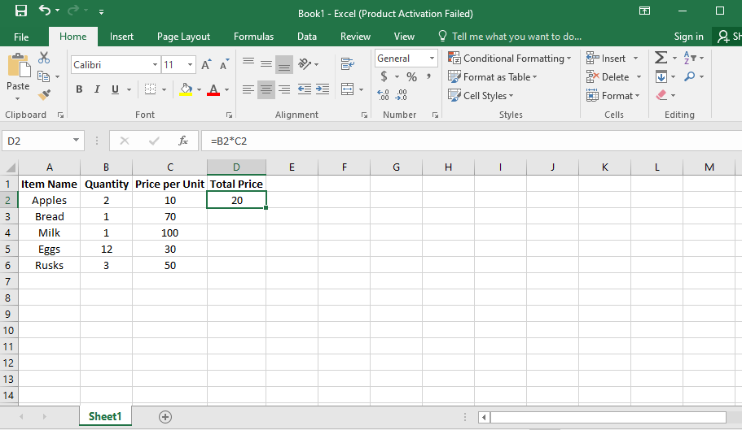Press Enter. Excel will calculate the total price for the first item.

**Task 3:**

1. Click on Cell D2 (where you just entered the formula).
2. Move your cursor to the bottom-right corner of the cell. It will turn into a small plus sign (⬜➕).
3. Click and drag the fill handle down to cover all rows with data (e.g., D6 if Release the mouse. Excel will automatically copy the formula for all items.
4. 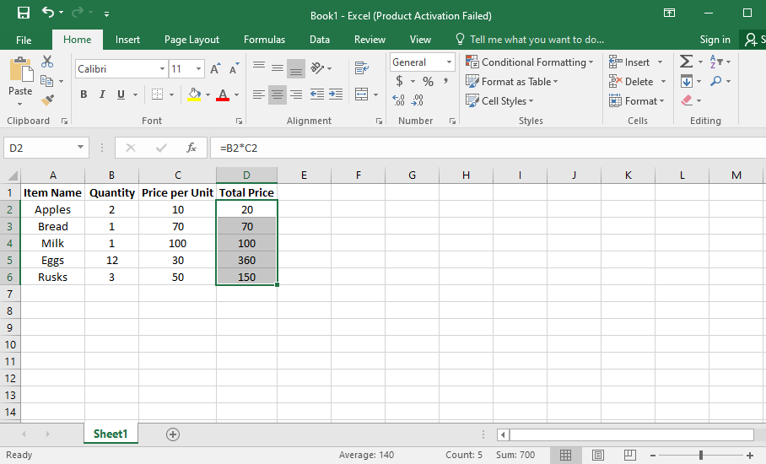You have five items).

**Task 4:**

1. Click on each Total Price cell (D2 to D6) and check that the formula references the correct row.
2. Ensure the calculated values are correct.
3. Click File > Save As.
4. Choose a location (e.g., Desktop or Documents).
5. Name the file (e.g., Grocery List.xlsx).
6. **Click Save.**